Meshailen Chetty

Boston Bedfordview

04HA2110994

**ERD Diagram – Boston Database**

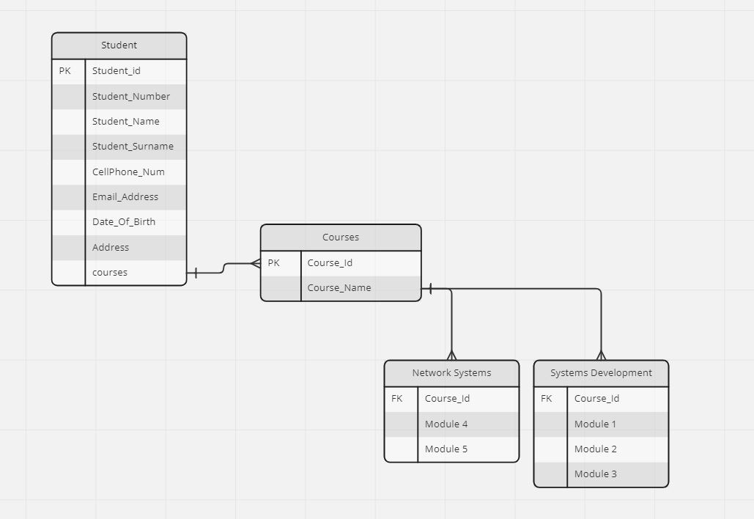

**The Business rules for the database:**

There aren’t any **auto populations** in the database as I do not want to assume information for the students but only when they choose the tertiary course it then auto -fills information based on the diploma selected.

**Creating dynamic picklist options**, there is a picklist to choose between courses as one of the database business rules.

**Validating data fields** falls under a business rule for selecting the correct date format used to capture students birth dates.

**Showing or hiding sections** is another business rule that Is being implemented by not showing the student ID as this is a serial variable and is used to identify students on the database so this is hidden from the forms when adding students.